SSRS for JIRA Technical Guide

# Purpose Overview

This project (SQL Server Reporting Services for JIRA) came out of the need to get some additional reporting out of our JIRA Cloud solution. In particular we have a single service desk with multiple components and are using the JIRA Agile (Scrum Board) solution. The piece of information that is not delivered with the JIRA Agile reports is a velocity reading per component, though we use that in our planning and delivery capabilities.

We then looked into how to get this data and the JIRA API solution looked to have the data we needed, but it was in JSON format and while we could get that data out it wasn’t nicely formatted and we would have had to write code to do the calculations. We use SSRS to format the report and provide the report on demand, however SSRS doesn’t support JSON.

# Solution Overview

So we built two main components: first a web service suite that works as an interface to the JIRA API solution returning XML to the client (something SSRS can consume) and second some SSRS reports to use those web services to do the calculations for component-based velocity calculations.

This should be expandable from here either via additional data returned (via data objects) or additional web methods (either more parameters on existing ones or more targeted web method calls).

# Issues in Development (and their Resolution)

## What sprint was the story completed in?

One question we need to ask of the API is what sprint the story was completed in (well normally the other way, for a given sprint what stories were completed in that sprint). The JIRA Agile REST API seems to provide the current state of the story rather than the state as at when the sprint was completed.

### Resolution

We currently do not have a resolution for this and this question has been asked to a wider audience via stackoverflow at: <http://stackoverflow.com/questions/34540888/is-there-a-way-to-determine-status-of-an-issue-at-the-end-of-a-sprint-with-jira>

# Setup Process

## SSRS-for-JIRA Web Services

### web.config

The web.config has a few parameters that need to be updated and then this can either be run locally in a development environment or it can be deployed to an environment of you choosing (if deployed the Reporting Services Reports would need their data sources updated or linked through).

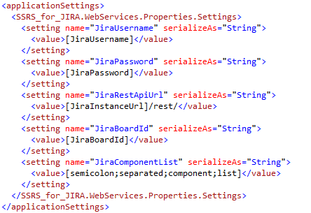

#### JiraUsername

This is the JIRA username to be used when connecting to the JIRA REST API.

#### JiraPassword

This is the password for the JIRA username to be used when connecting to the JIRA REST API.

#### JiraInstanceUrl

This is the URL of your JIRA instance.

#### JiraBoardId

This is the ID of your JIRA Agile Scrum Board.

#### JiraComponentList

This is a semicolon separated list of components that you want to run your reporting on.

## Reporting Services Reports

### Data Source

The data source should be changed from localhost to the location that you’ve deployed your SSRS-for-JIRA Web Services. This can be done by opening up the report file (.rdl) and amending the data source.

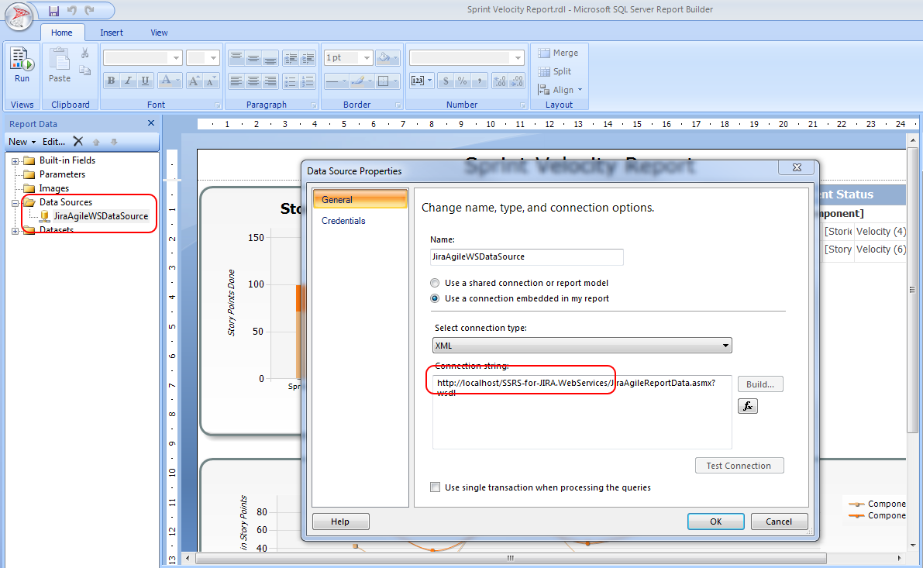

# Appendix: JIRA Agile General Information

## Links and Online Resources

* [Introduction to JIRA and Agile Project Management](https://www.youtube.com/watch?v=NrHpXvDXVrw)

# Appendix: JIRA Agile API Reference

## JIRA REST APIs

## JIRA Agile REST APIs

* [jira instance]/rest/agile/1.0/

## Links and Online Resources

* [Jira Agile REST API Documentation](https://docs.atlassian.com/greenhopper/REST/cloud/)
* [Jira REST API Documentation](https://docs.atlassian.com/jira/REST/latest/)
* [Connection to JIRA REST API with C#](http://maffelu.net/jira-basic-cjira-connection-using-rest/)
* [Converting JSON to XML](http://stackoverflow.com/questions/16562101/converting-json-to-xml)
* [Jira Agile REST API Authentication](https://developer.atlassian.com/jiradev/jira-apis/jira-rest-apis/jira-rest-api-tutorials/jira-rest-api-example-basic-authentication)
* [Jira Agile REST API Tutorials](https://developer.atlassian.com/jiradev/jira-apis/jira-rest-apis/jira-rest-api-tutorials/jira-rest-api-example-basic-authentication)

# Appendix: JSON.Net

## Links and Online Resources

* <http://stackoverflow.com/questions/814001/convert-json-string-to-xml-or-xml-to-json-string>
* [Newtonsoft Examples for JSON.Net](http://www.newtonsoft.com/json/help/html/ConvertJsonToXml.htm)

# Appendix: Web Services in SSRS

## Links and Online Resources

* [How to use Web Services as a Data Source in SSRS](http://bhushan.extreme-advice.com/webservice-as-datasource-in-ssrs/)